**cid:db31026c-87d4-4fb3-9eaa-a14b19e885e2Department of Humanities**

Attempt all Questions.

Name:__ROHAN NYATI_________________________Roll no:______R177219148____________________

**Q.1. Refer to the following mind map. 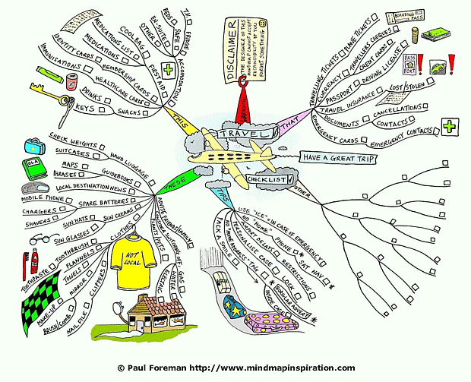Answer the questions that follow: [15 Marks]**

1. Deductive Passage on *Checklist*- (50-75 words)
2. Inductive Passage on *These-* (50-75 words)

………………………………………………………………………………………………………b.)Weight of suitcases to be checked for our hand luggage. Use maps and thrashes as guidebooks. Read local destination news. Mobile phones, chargers, shavers to be kept as spare batteries. Keep sun hats, sun glasses and sun cream. Keep toothbrush, toothpaste, flannels, towels, and make-up , brush/comb with mirrors, nail-file, clippers all these things necessary with clothes. Gas, water and electric appliances to be switched off. Inform Friends/family to take care of plants/pets. ………………………………………………………………………………………………………a.)For travelling checklist is must . We must ensure availability of proper documents including passports/id-cards, travelling tickets .Check currency such as travellers cheque, cash and credit cards. Keep spare batteries for mobile phones and shavers. Carry proper eatables like snacks and drinks. Ensure a First Aid Kit containing cool bag and medications.

…………………………………………………………………………………………………………………………………………………………………………………………………………………………………………………………………………………………………………………………………………………………………………………………………………………………………………………………………………………………………………………………………………………………………………………………………………………………………………………………………………………………………………………………………………………………………………………………………………………………………………………………………………………………………………………………………………………………………………………………………………………………………………………………………………………………………………………………………………………………………………………………………………………………………………………………………………………………………………………………………………………………………………………………………………………………………………………………………………………………………………………………………………………………………………………………………………………………………………………………………………………………………………………………………………………………………………………………………………………………………………………………………………………………

**Q2. Write a Precis` based on the following excerpt. Draft a Title for the same: [7.5+7.5marks]**

Has the Narendra Modi regime normalised violence in a way that could hurt the Prime Minister himself? Has he created a Frankenstein monster that he cannot destroy? That is the real question to ask, as we sit back and reflect on the Delhi violence that could have been a pogrom. It began on Sunday as a confrontation between police and protesters. After BJP leader Kapil Mishra’s provocation, it became a Hindu-Muslim riot on Monday. By Tuesday, it had become one-sided anti-Muslim violence that reminded everyone of 1984. I write these lines on Wednesday noon when there are some indications of the violence that engulfed the national capital for three days ebbing. Official [death toll](https://twitter.com/ThePrintIndia/status/1232581691702558721) at this moment is 24 – informal estimates put it at double this figure – but there are no fresh incidents of murderous assaults of the kind we witnessed on Monday and Tuesday. The violence that threatened to spread to other areas of East Delhi on Tuesday evening has been contained to the original hotspots in the northeast of Delhi. Mobs that were ruling the street Tuesday as Delhi Police personnel stood watching or joined them are finally being chased out. Our 24×7 crisis management and support team tells me that since Tuesday midnight, police are responding positively to their calls for help. The heroic 2 am [intervention](https://thewire.in/law/delhi-riots-give-injured-muslims-safe-passage-hc-directs-police-in-late-night-order)by the Delhi High Court to order police to allow safe passage so that the injured could be taken to the hospital has certainly helped. We may have just stepped back from the brink of another 1984-type pogrom in the national capital.

……………………………………………………………………………………………………… Delhi Anti-Muslim violence

It started as a confrontation between Police and protesters which soon turned out to be a Hindu- Muslim riot after statement of BJP leader Kapil Mishra . Next day it turned out to be anti-muslim violence. The violence continued for 3days. Official death tolls is 24 , however there haven't been any murder assault. Violence that was about to spread to other parts of east of delhi remained in northeast region. Our Police has helped to take the injured people to hospital.

.………………………………………………………………………………………………………………………………………………………………………………………………………………………………………………………………………………………………………………………………………………………………………………………………………………………………………………………………………………………………………………………………………………………………………………………………………………………………………………………………………………………………………………………………………………………………………………………………………………………………………………………………………………………………………………………………………………………………………………………………………………………………………………………………………………………………………………………………………………………………………………………………………………………………………………………………………………………………………………………………………………………………………………………………………………………………………………………………………………………………………………………………………………………………………………………………………………………

**Q3. Read the schedule of President Donald Trump’s visit: [20marks]**

President Donald Trump to arrive at Sardar Vallabhbhai International Airport,Ahmedabad—Sabarmati Ashram (Ahmedabad)—Namaste Trump Event at Motera Stadium—Emplane for Agra—Arrival at Agra—Visit to Taj Mahal—Emplane for Delhi—Arrive at Delhi—Ceremonial reception at Rashtrapati Bhavan—Wreath laying at the samadhi of Mahatma Gandhi at Rajghat—Meeting with Prime Minister Narendra Modi at Hyderabad House—Exchange of Agreements/Press Statement at Hyderabad House—Meeting with President Ram Nath Kovind at Rashtrapati Bhavan;

1. **Summarize the visit in not more than 100 words.**
2. **Draft a report on the key aspects of the visit in about 100 words.**

a.)President of The United States of America Donald Trump arrived at Sardar Vallabhbhai International Airport in Ahmedabad. From there he was escorted to the great Sabarmati Ashram from where he was taken for the Namaste Trump Event at Motera Stadium .After this he Emplaned for Agra ,to visit India’s pride Taj Mahal .Then he emplaned for Delhi where he had an Ceremonical reception at Rashtrapati Bhavan , where he presented wreath laying at the samadhi of Mahatma Gandhi at Rajghat .After that he had a meeting with our Prime Minister Narendra Modi at Hyderabad House. Where they had exchange of Agreements/Press Statement at Hyderabad House. After all this hectic events he atlast had a Meeting with President Ram Nath Kovind at Rashtrapati Bhavan. Atlast I would say that his visit was impactful and worthy for our Country India.

………………………………………………………………………………………………………b.)………………………… Motera Stadium ,Ahmedabad

……………………… Namaste Trump Event Date:22/3/20202…………………………………………………………………………………… On Friday, President of The United States of America Donald Trump arrived at Sardar Vallabhbhai International Airport in Ahmedabad. From there he was escorted to the great Sabarmati Ashram from where he was taken for the Namaste Trump Event at Motera Stadium. There he delivered an impactful speech and enlightened many people.

Sincerely,…………………………………………………………………………………………

Rohan Nyati

1st year CSE UPES

……………………………………………………………………………………………………………………………………………………………………………………………………………………………………………………………………………………………………………………………………………………………………………………………………………………………………………………………………………………………………………………………………………………………………………………………………

………………………………………………………………………………………………………………………………………………………………………………………………………………………………………………………………………………………………………………………………………………………………………………………………………………………………………………………………………………………………………………………………………………………………………………………………………………………………………………………………………………………………………………………………………………………………………………………………………………………………………………………………………………………………………………………………………………………………………………………………………………………………………………………………………………

………………………………………………………………………………………………………………………………………………………………………………………………………………………………………………………………………………………………………………………………………………………………………………………………………………………………………………………………………………………………………………………………………